
MINI PROJECT REPORT
CROWD DENSITY MONITORING AND MANAGEMENT SYSTEM
SUBMITTED BY,
NAME : KAWIN.D
REGISTER NUMBER : 922524243085
DEPARTMENT : ARTIFICIAL INTELLIGENCE AND
DATA SCIENCE
ACADEMIC YEAR : 2024 – 2028
YEAR / SEMESTER : III YEAR/ V

1. INTRODUCTION

1.1 Project Background
Public and semi-public spaces such as shopping malls, stadiums, transit hubs, religious gathering places, and event venues routinely need to know how many people are present relative to a safe capacity limit. Traditionally this has been done manually, with security personnel observing CCTV monitors, or not done at all until an incident has already occurred. The Crowd Density Monitoring and Management System is a full-stack software solution designed to automate this process from end to end using computer vision and web-based dashboards.
The system is organised as three cooperating layers — a web-based user interface, an application server that manages business logic and data, and an artificial-intelligence detection engine — reflecting sound engineering practice rather than a single, tightly coupled program.

1.2 Problem Statement
Manual crowd monitoring does not scale: a human operator cannot continuously watch multiple camera feeds, mentally compute occupancy against a location's rated capacity, and reliably notice the exact moment a safe threshold is crossed. This creates a real risk that overcrowding is discovered only after it becomes dangerous. The project addresses this by replacing continuous human observation with an automated pipeline that detects and counts people, computes an occupancy percentage, and raises an alert the moment a location crosses a defined risk threshold.

1.3 Objectives
- To automatically detect and count people in live camera streams, mobile camera feeds, and uploaded video recordings using an artificial-intelligence based object-detection model.
- To convert a raw people count into a meaningful occupancy percentage and a graded crowd-risk classification for each monitored location.
- To automatically raise and record alerts when a location's occupancy crosses a defined risk threshold, without requiring continuous human supervision.
- To provide role-based dashboards for camera management, live monitoring, alert handling, analytics, and reporting.
- To provide exportable compliance reports for a given location and date range.

1.4 Need for the System
Venue operators and safety teams need continuous, objective visibility into occupancy rather than periodic, subjective human estimates. An automated system removes the dependency on a person continuously watching a monitor, provides a permanent, timestamped historical record of crowd data for audits and compliance reporting, and can notify stakeholders the instant a threshold is crossed — something manual observation cannot reliably guarantee across multiple locations at once.

1.5 Scope
The implemented system covers user authentication and role-based access control; management of camera records of different types (fixed CCTV, mobile camera, and uploaded video); starting and stopping monitoring for a given camera; running artificial-intelligence based person detection on a single image, an uploaded video file, or a continuous live stream; storing every detection as a historical crowd-data record; automatic alert generation and acknowledgement; multi-period analytics and peak-hour analysis; and downloadable compliance reporting. The present scope is a single-organisation deployment rather than a distributed, multi-tenant platform.

1.6 Applications
- Shopping malls and retail stores — monitoring footfall against fire-safety occupancy limits.
- Stadiums, auditoriums, and event venues — tracking crowd build-up at entrances and stands.
- Transit hubs such as railway stations, bus terminals, and airports — identifying platform or concourse overcrowding.
- Religious and public gathering places — providing early warning of dangerous crowd density.
- Educational institutions and corporate campuses — general occupancy and safety monitoring of common areas.

2. KEY FEATURES
The following features are implemented and verifiable within the working application. Only features that are actually functional are listed; no feature has been assumed or invented.
- Secure Login Authentication: Token-based login, registration, secure session renewal, logout, and a forgot-password / reset-password workflow.
- Role-Based Access Control: Three distinct roles — Administrator, Operator, and Viewer — with different levels of access enforced both on the server and within the user interface.
- Dashboard: A summary dashboard presenting aggregate system status, including total cameras, people detected, average occupancy, and active alerts.
- Camera Management: Complete management of camera records — name, camera type, location, maximum capacity, and stream address — restricted to Administrator and Operator roles.
- Start / Stop Monitoring: Per-camera monitoring control that changes a camera's status between active, monitoring, inactive, and error states.
- Live Monitoring: A live monitoring interface that displays the latest and historical crowd data for each camera, including a real-time occupancy bar and live detection preview.
- Artificial-Intelligence Person Detection: An integrated detection engine that identifies and counts people present in a camera frame.
- Crowd Density and Occupancy Calculation: Automatic conversion of a detected people count into an occupancy percentage and a five-level crowd-risk classification against each camera's configured maximum capacity.
- Density Heat-map Generation: Generation of a visual density heat-map overlay highlighting zones of higher concentration within a frame.
- Automated Alert System: Automatic creation of an alert record when occupancy crosses a risk threshold, together with an alert listing, bulk acknowledgement, and a full-screen overcrowded alarm with an accompanying audible warning.
- Analytics: Daily, weekly, monthly, custom-range, and peak-hour analytics presented as interactive charts.
- Report Generation: Generation of downloadable PDF and spreadsheet reports for a selected camera and date range, including crowd-data summaries and alert history.
- User Management: Administrator-level listing, role and active-status control, and removal of user accounts, together with a self-service profile and password-change facility.
- Video Upload Analysis: Uploading a recorded video file for background, frame-sampled artificial-intelligence analysis.
- Fixed Camera and Mobile Camera Support: Support for ingesting a fixed CCTV stream, a mobile-device camera stream, and an uploaded video file, in addition to a single still image.
Capabilities that were not found to be functioning within the application — for example, hardware-accelerated inference, multi-organisation deployment, or push/SMS notification channels — are not claied here and are discussed later as directions for future enhancement.

3. MODULES
The application is organised into cohesive functional modules, each responsible for a distinct area of business logic. Every module described below corresponds to working functionality confirmed within the application.

3.1 Authentication Module
- Purpose: Handles user registration, login, secure token issuance, session renewal, logout, and password reset.
- Workflow: A user submits credentials through the login screen; the Authentication Module validates the credentials against stored user records, issues a signed access token together with a renewable session token, and returns the authenticated user's profile to the interface, which stores it for the duration of the session.
- Interface Provided: Endpoints for registration, login, session renewal, logout, and password recovery.
- Database Interaction: Reads and writes user account records, assigned roles, and active session tokens.

3.2 Camera Management Module
- Purpose: Provides complete management of camera records and starts or stops monitoring for a given camera.
- Workflow: An Administrator or Operator registers a camera with its name, type, location, capacity, and stream address; the record is persisted and the camera can subsequently be started, which changes its status to monitoring and makes it eligible for artificial-intelligence analysis.
- Interface Provided: Endpoints for listing, creating, updating, deleting, starting, and stopping a camera.
- Database Interaction: Reads and writes camera records, including type, location, configured capacity, stream address, and current status.

3.3 Monitoring Module
- Purpose: Bridges the user interface and the detection engine: retrieves live and historical crowd data, and coordinates video-upload and live-stream analysis.
- Workflow: The monitoring screen requests the latest reading for a camera, or triggers continuous stream analysis; each detection result produced by the detection engine is transmitted back to the Monitoring Module, which persists it and forwards it for automatic threshold evaluation.
- Interface Provided: Endpoints for retrieving the latest and historical crowd data, submitting detection results, initiating and stopping live-stream analysis, uploading a video for analysis, and validating a stream address.
- Database Interaction: Reads and writes historical crowd-data records, including people count, occupancy percentage, crowd level, and stored detection imagery.

3.4 Artificial-Intelligence Detection Module
- Purpose: Performs person detection on a supplied image, video, or live-stream frame and calculates occupancy from the resulting count.
- Workflow: An incoming frame is decoded and passed through a trained object-detection model restricted to identifying people; a de-duplication step removes duplicate detections of the same individual; the final count is converted into an occupancy percentage and a graded crowd-level classification; an annotated frame and a density heat-map are then produced and returned together with the detection result.
- Interface Provided: Endpoints for analysing a single image, a video file, and a continuous live stream, together with a stream-validation endpoint.
- Database Interaction: Does not access the database directly; detection results are transmitted to the Monitoring Module, which is responsible for persistence.

3.5 Alert Module
- Purpose: Detects when a camera's occupancy crosses a risk threshold and manages the resulting alert's lifecycle.
- Workflow: Each time new crowd data is recorded, the Alert Module compares the newly computed crowd level with the camera's previously known level; on a meaningful change, it creates an alert record with a descriptive message, the associated people count, and occupancy percentage. The alerts screen allows a user to acknowledge one or all outstanding alerts, and a dedicated full-screen alarm is triggered immediately when a camera reaches the most severe, overcrowded level.
- Interface Provided: Endpoints for listing alerts, listing only active alerts, retrieving an alert count, and acknowledging one or all alerts.
- Database Interaction: Reads and writes alert records, referencing the associated camera and the triggering crowd-data entry.

3.6 Analytics Module
- Purpose: Aggregates historical crowd data into daily, weekly, monthly, custom-range, and peak-hour statistics.
- Workflow: The analytics screen requests a chosen time range; the Analytics Module performs aggregate calculations over the stored crowd-data history and returns average and peak occupancy, crowd-level distribution, and hourly trend information, which is then rendered as interactive charts.
- Interface Provided: Endpoints for daily, weekly, monthly, custom-range, and peak-hour analytics.
- Database Interaction: Performs read-only aggregate queries over historical crowd-data records, typically grouped by camera and time period.

3.7 Report Generation Module
- Purpose: Generates downloadable compliance reports for a chosen camera and date range in either document or spreadsheet format.
- Workflow: A user selects a camera, a date range, and a desired format on the reports screen; the Report Generation Module compiles the relevant crowd-data and alert history into a formatted document or spreadsheet and returns it for download.
- Interface Provided: Endpoints for generating a document-format report and a spreadsheet-format report.
- Database Interaction: Reads historical crowd-data and alert records, and records metadata describing each generated report.

3.8 User Management Module
- Purpose: Provides administrative management of user accounts and self-service profile management.
- Workflow: An Administrator can list all registered users, toggle a user's active status, or remove a user account; any authenticated user may view and update their own profile and change their password.
- Interface Provided: Endpoints for listing users, retrieving the current user's profile, updating a user, toggling active status, changing a password, and deleting a user.
- Database Interaction: Reads and writes user account records together with their assigned role.

3.9 Audit Logging Module
- Purpose: Records key account and administrative actions for traceability, without adding delay to the originating request.
- Workflow: Significant actions — such as a login, a role change, or a deletion — are logged asynchronously in the background, so that audit recording never slows down the user-facing operation that triggered it.
- Interface Provided: Not directly exposed as a user-facing interface; invoked internally by other modules.
- Database Interaction: Writes audit records describing the acting user, the action performed, the affected entity, and the time of occurrence.

4. SYSTEM ARCHITECTURE
The system follows a layered architecture composed of three cooperating components that communicate through well-defined interfaces: a presentation layer, an application server, and an artificial-intelligence detection engine, backed by a relational database.

4.1 Presentation Layer
A responsive, browser-based dashboard providing the login and registration screens, and role-appropriate screens for the dashboard, camera management, live monitoring, alerts, analytics, reports, user management, settings, and profile. Application state such as the authenticated session and interface theme is managed centrally, and all data requests are routed through a single, consistent communication layer.

4.2 Application Server
A secure server that exposes the business functionality of the system — authentication, camera management, monitoring, alerts, analytics, reports, and user management — enforces stateless, token-based authentication and role-based authorisation, and persists all application data to the relational database.

4.3 Artificial-Intelligence Detection Layer
A dedicated detection service that loads a trained object-detection model at start-up and accepts a single image, an uploaded video, or a continuous live stream, performs person detection, computes occupancy, and transmits the result back to the application server so that it can be stored centrally.

4.4 Database Layer
A relational database stores user accounts and roles, session tokens, camera records, historical crowd-data readings, alerts, and generated report metadata, together with an audit trail, with indexing applied to the high-traffic crowd-data and alert tables to keep dashboard and analytics queries responsive.

4.5 Communication Flow
The presentation layer communicates with the application server for all business data using authenticated requests, and separately triggers the detection layer to perform analysis. The detection layer, in turn, reports its results back to the application server so that every detection is centrally and consistently recorded.

5. IMPLEMENTATION

5.1 Presentation Layer Implementation
Navigation between screens is centrally controlled, with unauthenticated users automatically redirected to the login screen and role-restricted screens, such as camera management and user management, made accessible only to appropriately privileged roles. The authenticated session is held in a central application state, and every outgoing request automatically attaches the current session token; when a token has expired, it is transparently renewed so that a user is not unexpectedly signed out during normal use.

5.2 Application Server Implementation
Each functional area — authentication, camera management, monitoring, alerts, analytics, reports, and user management — follows a consistent layered design in which an incoming request is handled, validated, delegated to the relevant business logic, and translated into a persisted record, with a uniform response format used throughout so the presentation layer can process every response consistently.

5.3 Authentication and Security Implementation
User sessions are secured using signed, time-limited access tokens, verified on every incoming request before it is permitted to reach business logic. Stored passwords are never kept in plain text; they are transformed using a one-way cryptographic hashing algorithm, with the computational cost of hashing deliberately tuned to balance security strength against acceptable login response time.

5.4 Application Programming Interface Design
Every operation exposed by the application server returns a consistent response structure indicating success or failure, an accompanying message, and the relevant data payload, which simplifies error handling on the presentation layer. Cross-origin access is centrally governed by an externally configurable list of permitted origins, allowing the same server build to be safely used with different deployment environments.

5.5 Occupancy Calculation Logic
Occupancy is calculated as a direct function of the number of people detected in a frame and the configured maximum capacity of the corresponding camera. The resulting percentage is then mapped to one of five graded crowd-risk levels — Low, Medium, High, Critical, and Overcrowded — which drives both the visual indicators on the dashboard and the automatic alerting logic.

5.6 Alert Generation Logic
The Alert Module retains the most recently known crowd level for each camera and creates a new alert only when that level genuinely changes, rather than on every individual detection cycle. This design avoids flooding the alert history with repeated entries for a camera that remains steadily at the same crowd level.

5.7 Video and Stream Processing
An uploaded video is processed in the background, with frames sampled at intervals up to a defined maximum, so that very large recordings do not exhaust available memory. A continuously monitored live stream, by contrast, is handled through a single, persistent connection that is read in small batches on a background thread until monitoring is explicitly stopped, which avoids the overhead and intermittent failures associated with repeatedly reconnecting to a live camera source.

5.8 Database Design
The relational schema defines clear foreign-key relationships between cameras, their historical crowd-data readings, and the alerts derived from them, with cascading behaviour ensuring that related records remain consistent. Targeted indexes on the camera-and-time and crowd-level columns of the crowd-data table, and on the corresponding columns of the alert table, keep dashboard and analytics queries responsive as historical data accumulates. One stored column was specifically widened during development after a data-truncation issue was identified while testing storage of larger detection images, an example of the schema being refined through real testing rather than defined once and left unexamined.

6. OUTPUT SCREENSHOTS
The following screens are implemented and functioning within the deployed application, reachable through the project's live demonstration link. Actual screen captures of the running application are presented below, together with a brief professional explanation of each.
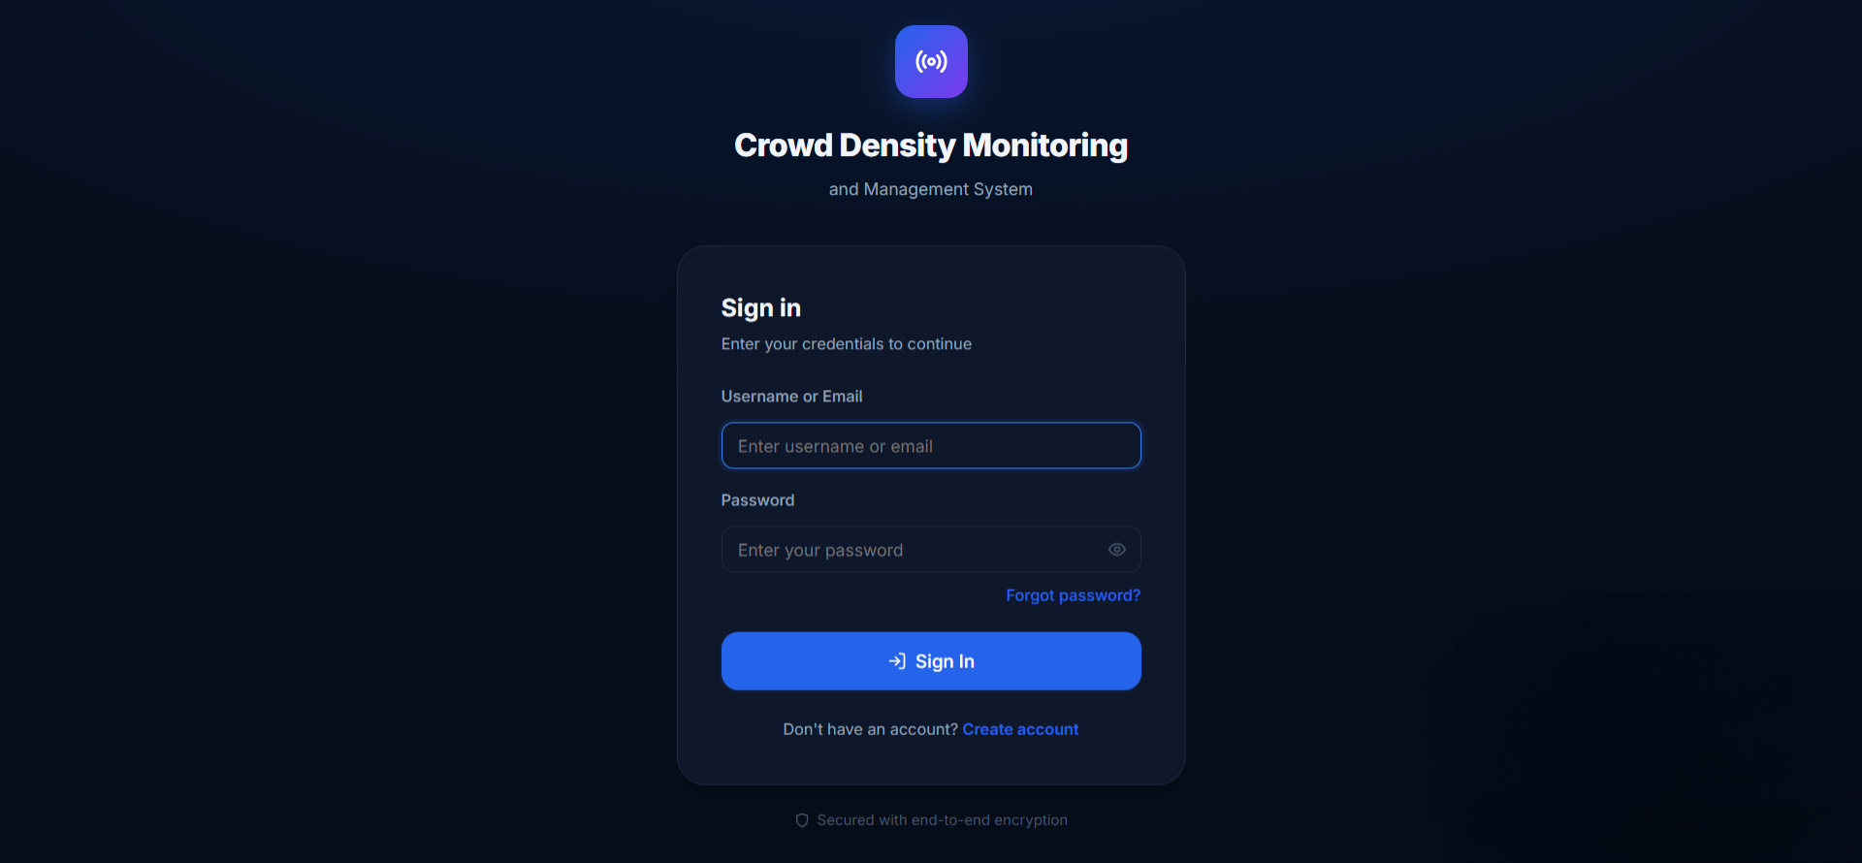
Figure 6.1: Login Page
The login screen authenticates a registered user against the system using their credentials, and on success establishes a secure session that grants access to the role-appropriate areas of the application.
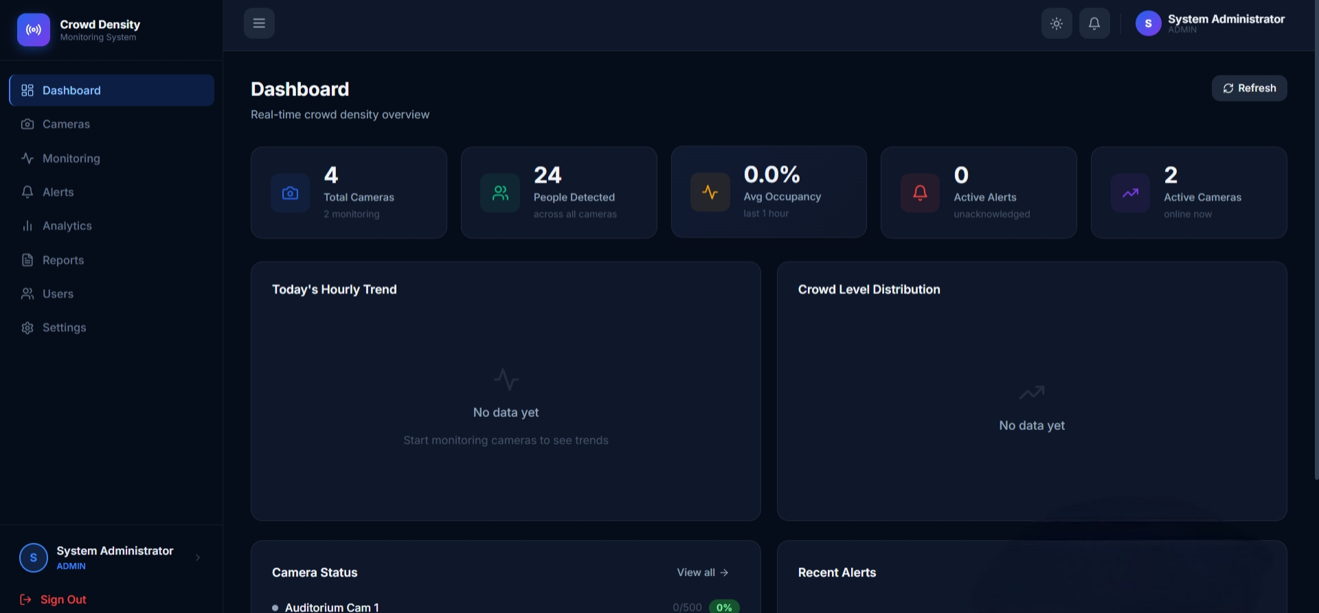
Figure 6.2: Dashboard
The dashboard presents a real-time, at-a-glance summary of the system: total cameras configured, people detected across all cameras, average occupancy over the past hour, and the number of unacknowledged active alerts, together with camera status and recent alert summaries.
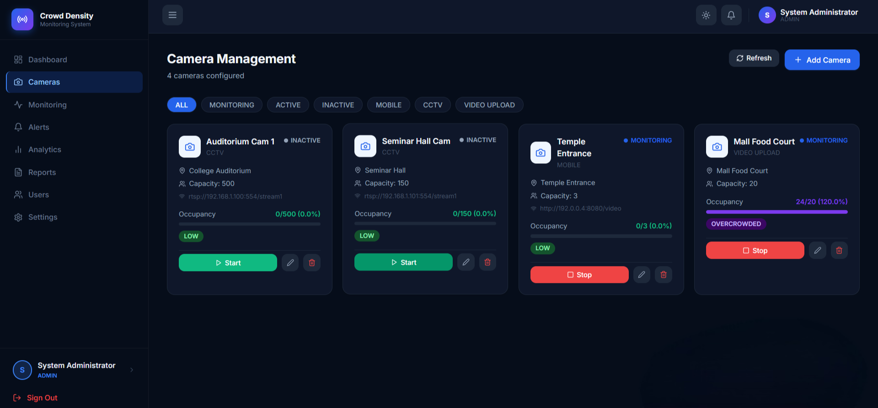
Figure 6.3: Camera Management
The camera management screen lists every configured camera together with its type, location, configured capacity, current occupancy, and status, and allows an authorised user to add, edit, remove, start, or stop a camera.
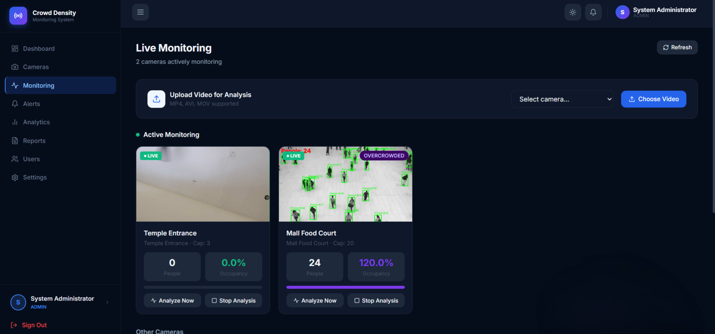
Figure 6.4: Live Monitoring
The live monitoring screen displays cameras that are actively being analysed, showing a live annotated preview with detected individuals outlined, the current people count, occupancy percentage, and the assigned crowd-risk level.
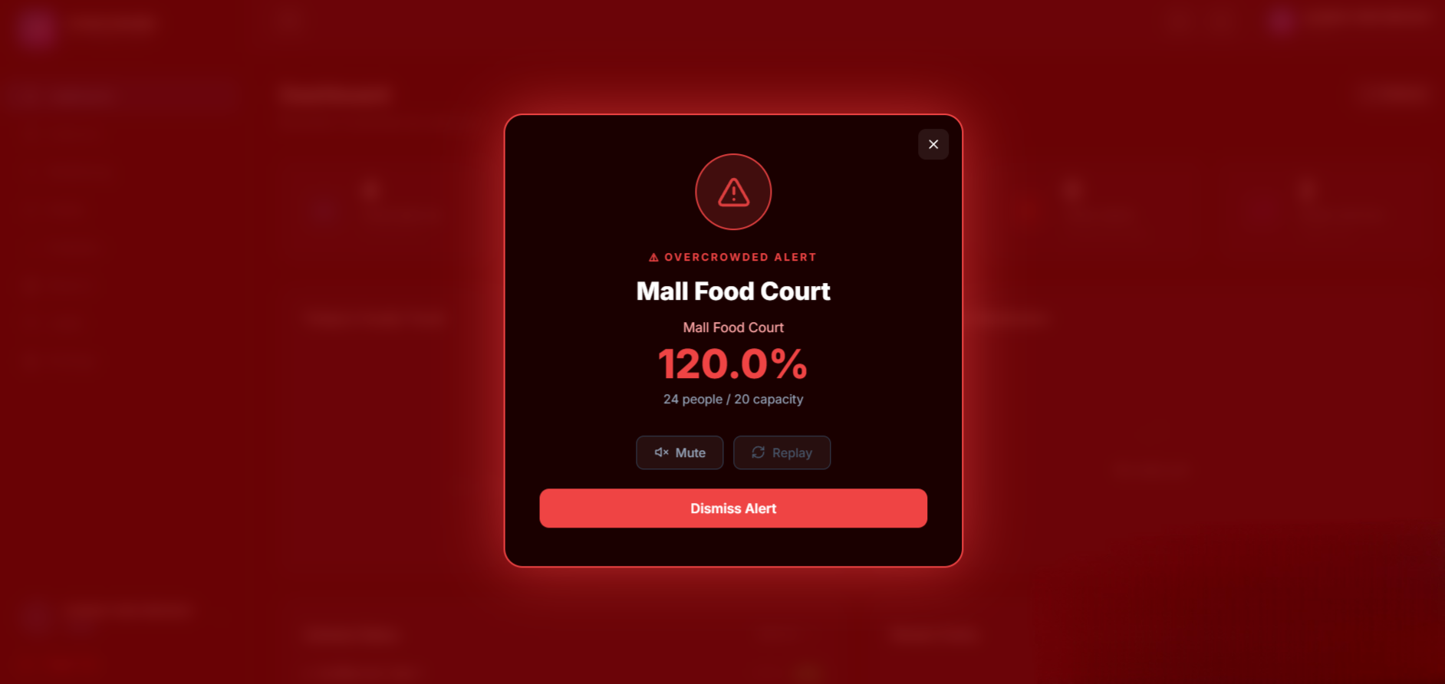
Figure 6.5: Alert Popup
When a monitored location reaches the most severe, overcrowded classification, a full-screen alert is presented immediately, displaying the affected location, its current occupancy percentage, and the underlying people count against its configured capacity, together with options to mute, replay, or dismiss the alert.
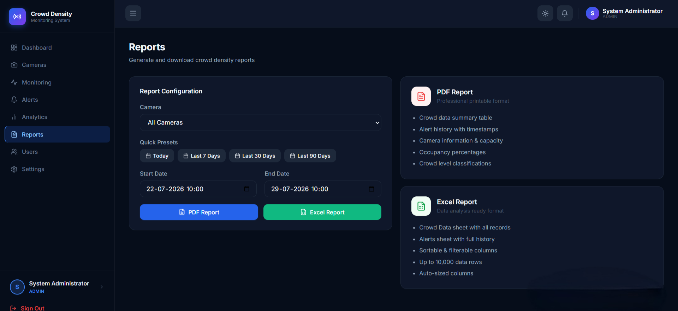
Figure 6.6: Reports
The reports screen allows a user to select a camera, a date range — either through quick presets or a custom range — and a desired output format, and then generate a downloadable document-format or spreadsheet-format compliance report.
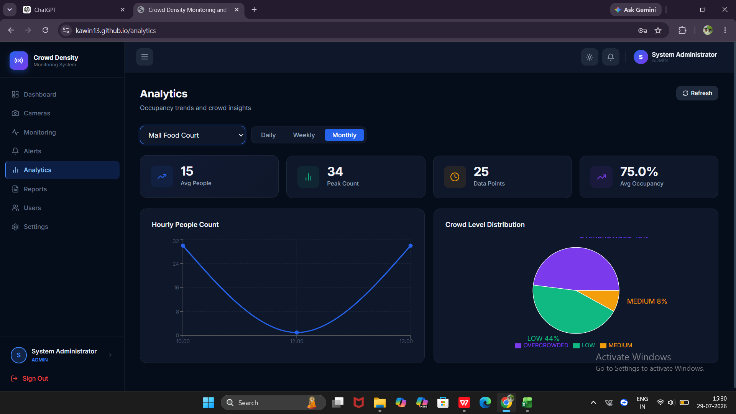
Figure 6.7: Analytics
The analytics screen presents daily, weekly, monthly, and peak-hour occupancy trends as interactive charts — including an hourly people-count trend and a crowd-level distribution breakdown — allowing a user to review historical crowd behaviour for a selected camera or across all cameras.
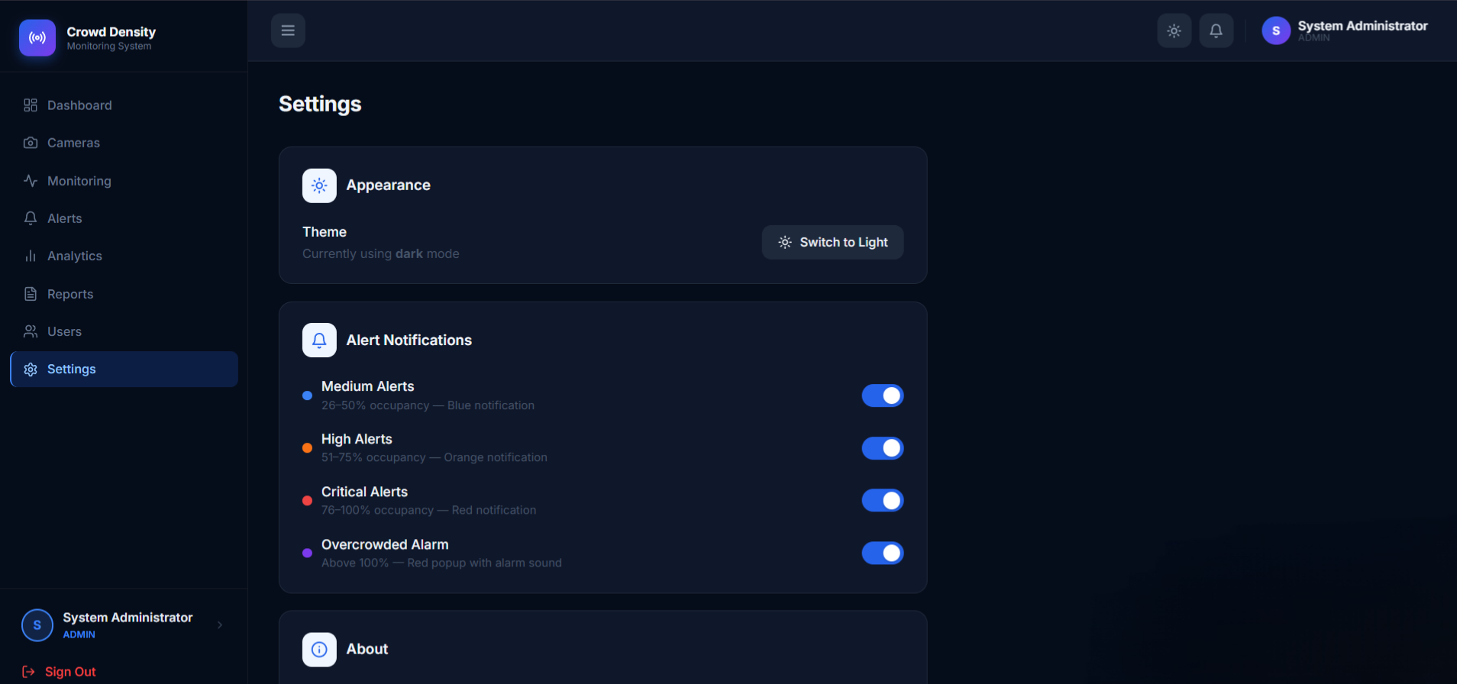
Figure 6.8: Settings
The settings screen allows an authenticated user to configure application-level preferences, such as switching the interface theme, and to control which severity levels of alert trigger a notification.
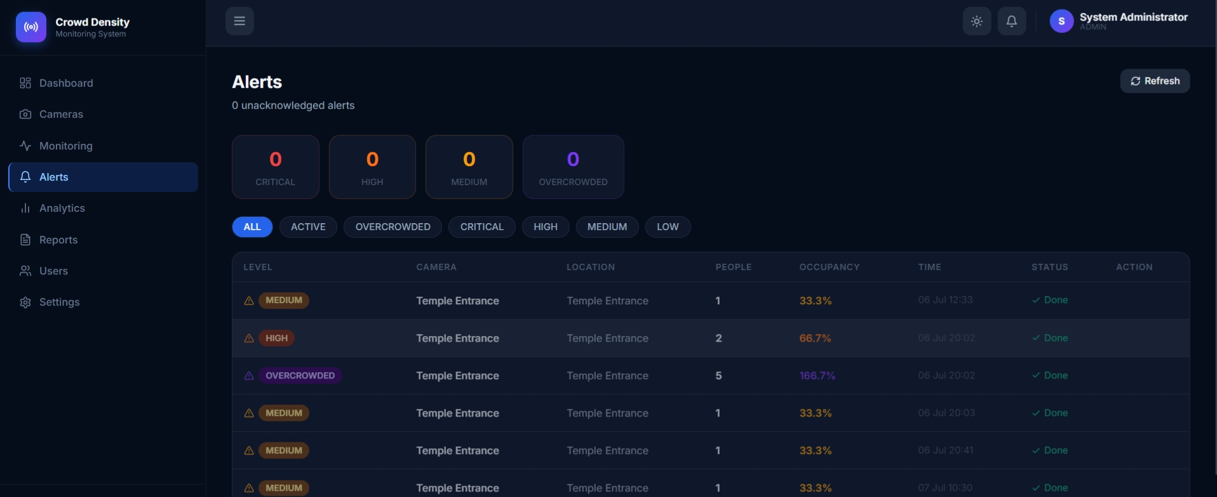
Figure 6.9: Alerts
The alerts screen lists every alert raised by the system, grouped by severity, together with the affected camera, location, detected people count, occupancy percentage, timestamp, and acknowledgement status, and allows an authorised user to acknowledge outstanding alerts.

7. DIAGRAMS
The following diagrams illustrate the architecture and workflow of the system in a manner consistent with standard engineering project documentation.

7.1 System Architecture / Data Flow Diagram
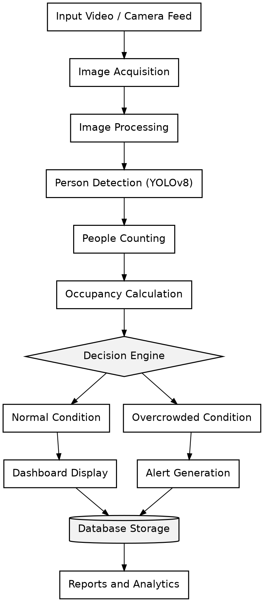
Figure 7.1: System Architecture and Data Flow

7.2 Use Case Diagram
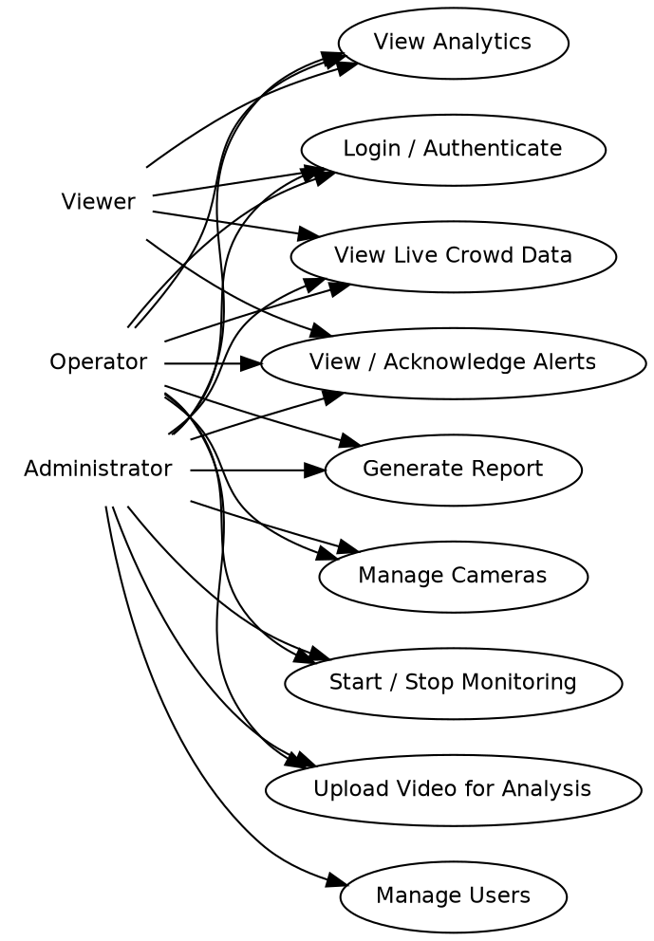
Figure 7.2: Use Case Diagram — Administrator, Operator, and Viewer

7.3 Sequence Diagram — Live Analysis Workflow
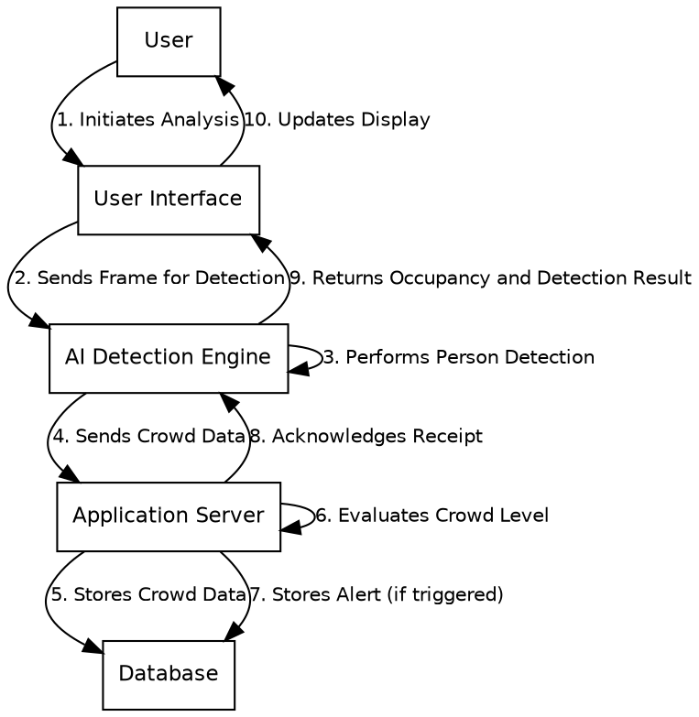
Figure 7.3: Sequence Diagram — Analysis Request to Dashboard Update

7.4 Component Diagram
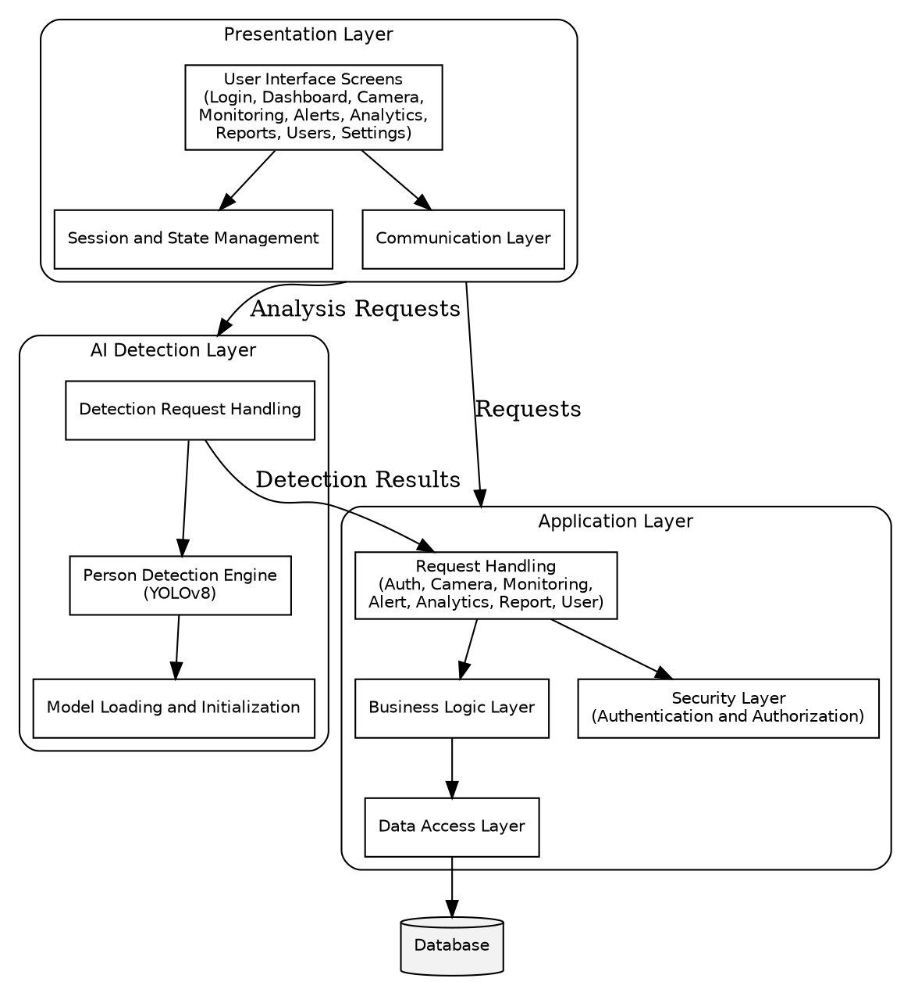
Figure 7.4: Component Diagram — Layered Module Composition

8. SOFTWARES USED
The following categories of development, build, and deployment software were used in developing and operating the system:
- A source-code editor / integrated development environment for writing and debugging the presentation layer, application server, and detection engine.
- Git and GitHub — version control and repository hosting for the project source.
- A build and dependency-management tool for compiling and packaging the application server.
- A package manager and development toolchain for building and running the presentation layer.
- A Python package manager for installing the dependencies of the detection engine.
- A relational database server and an accompanying administration tool for designing and inspecting the database schema.
- A containerisation platform and an orchestration tool for building and running all components of the system together in a consistent environment.
- A REST client used during development to exercise and verify the application server's interface.

9. TECHNOLOGY STACK
The system is built using a combination of modern, well-established technologies, each selected for a specific role within the architecture.

9.1 A Component-Based User-Interface Library
- Purpose: Builds the single-page dashboard application and all of its feature screens.
- Why Selected: A component-based architecture is well suited to a multi-screen, role-aware dashboard that must reflect frequent live data updates.

9.2 A Modern Front-End Build Tool
- Purpose: Provides the development server and production build process for the presentation layer.
- Why Selected: Enables fast development iteration and produces an optimised bundle for deployment.

9.3 An HTTP Client Library
- Purpose: Handles all communication between the presentation layer and the application server.
- Why Selected: Supports request and response interception, used here to attach session credentials automatically and to renew an expired session transparently.

9.4 A Charting Library
- Purpose: Renders analytics and dashboard trend charts.
- Why Selected: Integrates cleanly with the presentation layer's component state to display live and historical data visually.

9.5 A Modern, Object-Oriented Application Framework
- Purpose: Provides the foundation for the application server's business logic and web interface.
- Why Selected: Its layered, convention-driven design accelerates the development of a secure, well-structured server application.

9.6 A Security Framework with Token-Based Authentication
- Purpose: Provides authentication and authorisation for the application server.
- Why Selected: A widely adopted, thoroughly reviewed security framework reduces the risk of implementing authentication incorrectly from first principles.

9.7 An Object-Relational Mapping Framework
- Purpose: Maps application data structures to relational database tables.
- Why Selected: Reduces repetitive data-access code while keeping the underlying relational schema explicit and well structured.

9.8 A Relational Database Management System
- Purpose: Serves as the system's primary data store.
- Why Selected: A mature, dependable database engine well suited to the project's structured, relationally linked data.

9.9 A High-Performance Web Framework for the Detection Service
- Purpose: Provides the web interface of the artificial-intelligence detection engine.
- Why Selected: Its asynchronous design efficiently handles image, video, and live-stream analysis requests.

9.10 A Real-Time Object-Detection Model
- Purpose: Performs person detection within a supplied frame.
- Why Selected: Offers a practical balance of detection accuracy and processing speed suitable for near-real-time analysis.

9.11 A Computer-Vision Processing Library
- Purpose: Performs image and video decoding, annotation, and stream capture.
- Why Selected: A standard, dependable library for reading live video sources, drawing detection outlines, and constructing the density heat-map.

9.12 A Deep-Learning Runtime
- Purpose: Provides the underlying numerical engine on which the detection model executes.
- Why Selected: Required to load and run the trained detection model efficiently.

9.13 Document and Spreadsheet Generation Libraries
- Purpose: Produce downloadable document-format and spreadsheet-format reports.
- Why Selected: Mature libraries capable of generating professional report files without relying on external office software.

9.14 A Containerisation and Orchestration Platform
- Purpose: Packages and runs all components of the system together in a consistent, reproducible environment.
- Why Selected: Allows the presentation layer, application server, detection engine, and database to be built and started together, matching the system's layered architecture.
10. ADVANTAGES AND DISADVANTAGES

10.1 Advantages
- Fully automated occupancy tracking removes dependence on continuous human observation of camera feeds.
- A clearly layered architecture allows the presentation layer, application server, and detection engine to be operated, restarted, or scaled independently.
- Defensive handling of communication with the detection engine allows the dashboard to continue functioning gracefully even if the detection engine is temporarily slow or unreachable.
- Stateless, token-based authentication avoids server-side session storage and supports horizontal scaling.
- A dedicated de-duplication step reduces the risk of the same individual being counted more than once within a crowded frame.
- Targeted database indexing keeps analytics and alert queries responsive as historical data accumulates.
- Downloadable compliance reports support audit requirements without manual data compilation.

10.2 Existing Limitations
- Detection operates on individual frames without cross-frame tracking, so an individual moving between frames is not followed as a continuous trajectory; only an instantaneous count is available at any moment.
- The detection engine currently runs as a single processing worker, which limits throughput to one analysis pipeline per deployed instance.
- The lightweight detection model was chosen for processing speed, and may be less accurate than a larger model on extremely dense or heavily occluded crowds.
- Password-hashing strength was deliberately tuned toward faster login response, a measured trade-off against maximum theoretical security strength.
- A comprehensive, automated test suite covering the application server and detection engine was not found to be in active use at the time of analysis.

10.3 Possible Future Improvements
- Introduce multi-frame person tracking to further reduce double-counting and enable dwell-time analytics.
- Support hardware-accelerated inference and multiple parallel detection workers for higher-throughput, multi-camera deployments.
- Add push or short-message notification channels for alerts, in addition to the current in-application banner and alarm mechanism.
- Introduce a comprehensive automated test suite to guard against regressions as the system evolves.
- Extend the system toward multi-organisation deployment, allowing several independent organisations to use isolated instances of the same platform.

11. CONCLUSION
The Crowd Density Monitoring and Management System successfully demonstrates a complete, working pipeline from raw camera input to actionable, role-based operator insight. The system implements user authentication and role-based access control, camera lifecycle management, artificial-intelligence based real-time person detection across fixed, mobile, and uploaded-video sources, automatic occupancy calculation with graded risk classification, threshold-driven alerting, multi-period analytics, and downloadable compliance reporting — all confirmed directly through examination of the working application rather than assumed.
Architecturally, the decision to build the presentation layer, application server, and detection engine as independently operable components, coordinated through a container-orchestration platform, reflects an engineering approach closer to a production system than a single-script prototype. Evidence of deliberate refinement — tuning of password-hashing strength, correction of a data-storage limitation discovered during testing, and the move to a persistent connection for live-stream analysis — shows the system evolving through genuine debugging and performance tuning rather than being written once and left unexamined.
Developing this project provided practical experience across the full technology stack: designing a normalised relational schema with appropriate indexing; implementing stateless, token-based authentication and role-based authorisation; integrating a computer-vision detection model into a responsive, real-time service; and building a role-aware web dashboard that reacts to live data from both the application server and the detection engine. The identified limitations — the absence of cross-frame tracking, single-worker detection throughput, and the absence of a comprehensive automated test suite — are clearly identifiable directions for future work rather than fundamental design flaws, and the system's layered architecture is well positioned to accommodate them.

12. REFERENCES
- Project Title: Crowd Density Monitoring and Management System
- GitHub Repository: https://github.com/Kawin13/Crowd-density-monitoring-and-management-system
- Frontend: https://kawin13.github.io/Crowd-Density-Monitoring/
- Backend API: https://crowd-density-monitoring-1.onrender.com
- AI Service: https://crowd-density-monitoring.onrender.com
- Database: Aiven MySQL Cloud Database
- Technologies: React, Vite, Spring Boot, FastAPI, YOLOv8, OpenCV, MySQL, JWT

13. PROJECT/GITHUB LINK
GitHub Repository:
https://github.com/Kawin13/Crowd-density-monitoring-and-management-system
Live Demo:
https://kawin13.github.io/Crowd-Density-Monitoring/
THANK YOU !!

